**Screenshot – Assignment 9 by Venneti Kalyana Chakravarthy**

**Read the dataset from the below link:**

https://raw.githubusercontent.com/guipsamora/pandas_exercises/master/06_Stats/US  
_Baby_Names/US_Baby_Names_right.csv

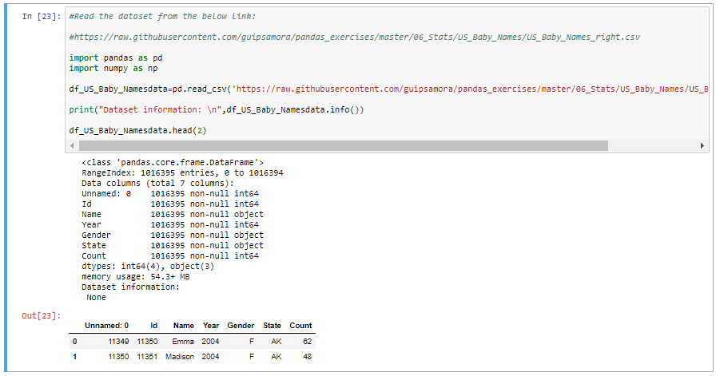

**Question 1:** Delete unnamed columns

**Solution:**

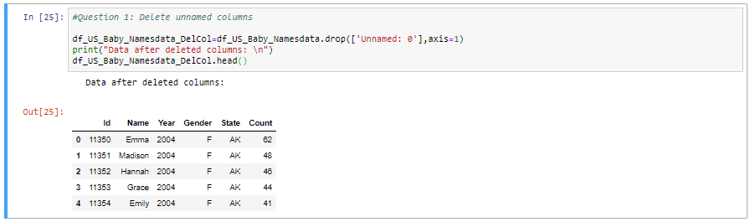

**Question 2:** Show the distribution of male and female.

**Solution:**

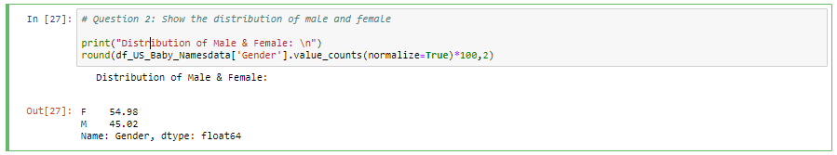

**Question 3:** Show the top 5 most preferred names

**Solution:**

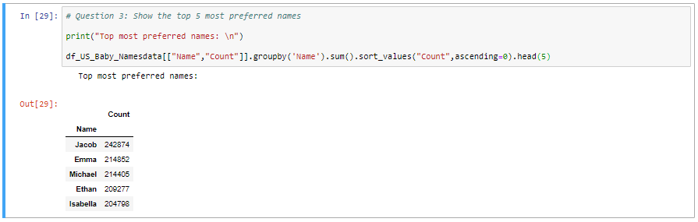

**Question 4:** What is the median name occurence in the dataset

**Solution:**

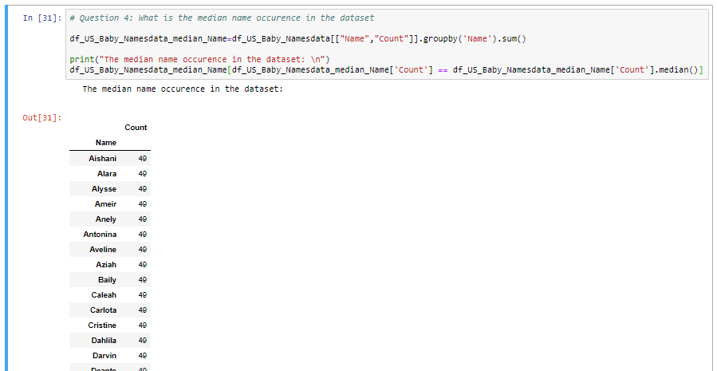

**Question 5:** Distribution of male and female born count by states.

**Solution:**

